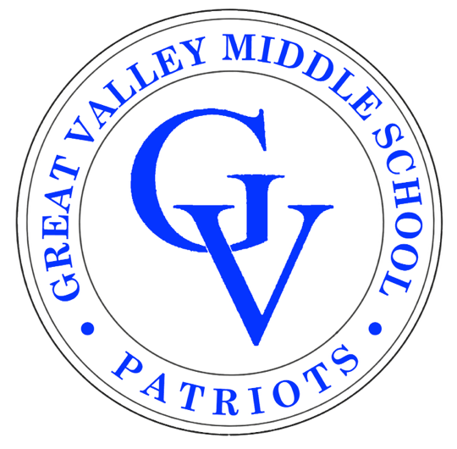PTO Handbook

2022-2023

Greetings from the Great Valley Middle School PTO!

Our Parent Teacher Organization exists to serve the GVMS community by promoting communication and involvement among parents/guardians, teachers, and administrators.

We continue to provide programs, activities & teacher support due to the efforts of our wonderful volunteers! Please consider volunteering! Every volunteer has a gift to share. The gift of time is most appreciated and the students & staff benefit from the partnership. Watch your email and our Facebook page for ways to get involved.

For your convenience this handbook has: GVMS staff directory, a list of PTO supported activities, events, and fundraisers, and other helpful information.

GVMS PTO has four general meetings throughout the school year. All are welcome to attend. PTO minutes and a copy of the budget can be found on the PTO website after each meeting.
Thank you for your time and continued support. We look forward to working with you!
Like us on Facebook (GVMS PTO) and refer to our website www.gvmspto.org for updates and information.

Respectfully,

Your 2022-2023 GVMS Executive PTO Board
Tiana Threadgill, Advisor
Alpa Jani, Co-President
Roxanne Cockerham, Co-President
Cristina Hartley, Vice President
Meenakshi Krishnamurthy, Treasurer
Bobbijo Pinnelli, Recording Secretary
Christine Bradley, Corresponding Secretary

Please mark the following GVMS PTO meetings on your calendar:

General PTO meeting dates for 2022-2023
(Meetings are held in the library and via zoom)

10/6 (9am), 1/5 (1pm), 3/2 (6:30), 5/4 (1pm)

Great Valley School District

2022-2023

Great Valley Middle School
225 North Phoenixville Pike
Malvern, PA 19355
610-644-6440
Principal – Edward Souders, Ed.D. - esouders@gvsd.org
Asst. Principal – Sharon Cohen Ed.D. - shcohen@gvsd.org

Attendance
For absences from the Middle School please the school via email - GVMSattendance@gvsd.org
In the absence of an email, the school will call home to verify the student's absence.

Administrative/Business Office
Great Valley School District
301 Lindenwood Drive, Suite 210
Malvern, PA 19355
610-889-2125

- Daniel F. Goffredo, Ed.D., Superintendent – dgoffredo@gvsd.org – 610-889-2125 x/ 52112 - https://www.gvsd.org/Domain/12
- Business Office Information - https://www.gvsd.org/Page/181
- The Great Valley Board of School Directors welcomes questions and comments from the community. To that end, community members may email the entire Board at GVBoard@gvsd.org, or may call (610) 889-2125, ext. 52112, or ext. 52123. https://www.gvsd.org/domain/24

GVMS Teachers & Staff 2022-2023

Acker, Brian | backer@gvsd.org
Amodei, Emily | eamodei@gvsd.org
Bagnarelli, Mike | mbagnarelli@gvsd.org
Bedell, Joann | jbedell@gvsd.org
Bender, Michael | mbender@gvsd.org
Benner, Kelly | kbenner@gvsd.org
Bergman, Jeremy | jbergman@gvsd.org
Beyer, Emily | ebeyer@gvsd.org
Birenbaum, Mike | mbirenbaum@gvsd.org
Brogan, Derek | dbrogan@gvsd.org
Brown, Owen | obrown@gvsd.org
Bullard, Sue | sbullard@gvsd.org
Byrne, Maryellen | mbyrne@gvsd.org
Cellini, Mark | mcellini@gvsd.org
Cinciripino, Larry | lcinciripino@gvsd.org
Cini, Lara | lcini@gvsd.org
Cohen, Sharon | shcohen@gvsd.org
Crabree, Alyson | acrabtree@gvsd.org
Darlak, Karen | kdarlak@gvsd.org
DeMitis, Alyssa | ademitis@gvsd.org
DeVirgilio, Jon | jdevirgilio@gvsd.org
Dietz, Elidari | edietz@gvsd.org
Dippell, Andrew | adippell@gvsd.org
Eidell, Kelly | keidell@gvsd.org
Fabii, Roseanna | rfabii@gvsd.org
Famous, Theresa | tfamous@gvsd.org
Feinman, Nancy | nfeinman@gvsd.org
Fichter, Kelly | kfichter@gvsd.org
Fredrickson, Jane | jfredrickson@gvsd.org
Freeman, Lisa | lfreeman@gvsd.org
Gambino, Donna | dgambino@gvsd.org
Geesey-Peters, Adria | ageesey-peters@gvsd.org
Gillard, Emily | egillard@gvsd.org
Gimbel, Donna | dgimbel@gvsd.org
Groh, Rebekah | rgroh@gvsd.org
Harris, Molly | mharris@gvsd.org
Hernandez-Sanchez, Roberto | rhsanchez@gvsd.org
Illig, Jen | jillig@gvsd.org
Kheradi, Jessica | jkheradi@gvsd.org
Kratzer, Sherri | skratzer@gvsd.org
Leary, Tim | tleary@gvsd.org
Leininger, Michelle | mleininger@gvsd.org
Lester, Aura | alester@gvsd.org
Mack, Laura | lmack@gvsd.org
Malseed, Heather | hmalseed@gvsd.org
Marabella, Lauren | lmarabella@gvsd.org
McDonald, Laura | lmcdonald@gvsd.org
McGovern, Heather | hmcgovern@gvsd.org
McKendrick, Helena | hmckendrick@gvsd.org
Meluskey, Michael | mmeluskey@gvsd.org
Miller, Lisa | lmiller@gvsd.org
Morellia, Mary | mmorelli@gvsd.org
Motz, Patrice | pmotz@gvsd.org
Motzer, Jennifer | jmotzer@gvsd.org
Mrochko, Diana | dmrochko@gvsd.org
Myers, Brinton | bmyers@gvsd.org
Nystrom, Christene | cnystrom@gvsd.org
Oh, Angelina | aoh@gvsd.org
Orlowski, Marj | morlowski@gvsd.org
Ortenzi, Ann | aortenzi@gvsd.org
Pratt, Elizabeth | epratt@gvsd.org
Pridgen, Damita | dpridgen@gvsd.org
Raymond, Melissa | mraymond@gvsd.org
Riley, Craig | criley@gvsd.org
Robinson, Ben | brobinson@gvsd.org
Rostick, Laura | lrostick@gvsd.org
Roy, Brenda | broy@gvsd.org
Ruckelshaus, Peter | pruckelshaus@gvsd.org
Scholz, Karen | kscholz@gvsd.org
Schultz, Jennifer | jschultz@gvsd.org
Schultz, Matthew | mschultz@gvsd.org
Scibilia, Bettina | bscibilia@gvsd.org
Search, Adam | asearch@gvsd.org
Search, Ann | annsearch@gvsd.org
Sindaco, Chad | csindaco@gvsd.org
Smith, Erin | esmith@gvsd.org
Souders, Edward | esouders@gvsd.org
Stamato, Maria | mstamato@gvsd.org
Stewart, Bob | rstewart@gvsd.org
Trahey, Michael | mtrahey@gvsd.org
Urban, Jaime | jurban@gvsd.org
Vastardis, Terri | tvastardis@gvsd.org
Wagner, Julie | jlwagner@gvsd.org
Weiner, Mathieu | mweiner@gvsd.org
Whitelock, Shawn | swhitelock@gvsd.org
Wilson, Brianne | bwilson@gvsd.org
Wise, Matthew | mwise@gvsd.org
Wyner, Keith | kwyner@gvsd.org
Yobouet, Nguessan | nyobouet@gvsd.org
Young, Neil | nyoung@gvsd.org
Zachar, Dana | dzachar@gvsd.org

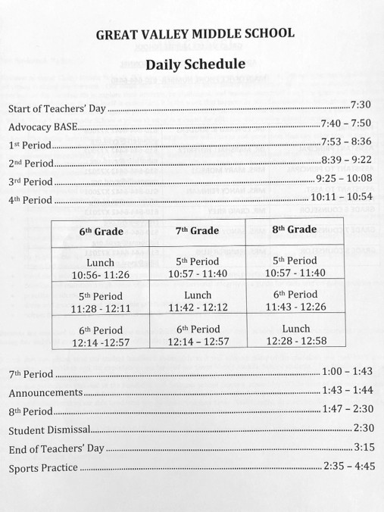

GVMS School Map
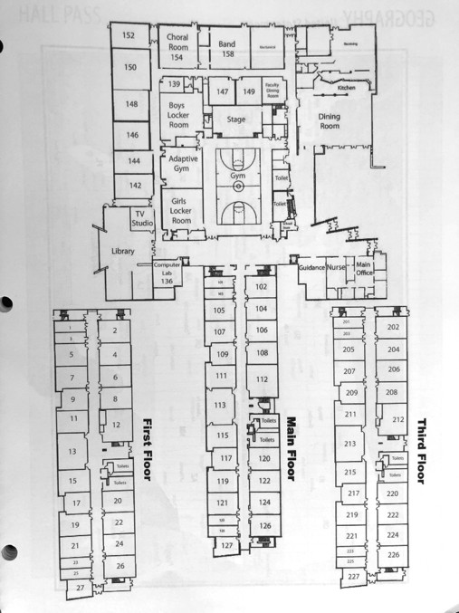

.

GVMS Parent Teacher Organization

Fundraisers:
Just Write a Check Corporate Matching: (year round) | Your Just Write a Check is confidential, tax deductible and can be matched by your employer (if they run a corporate matching program). THANK YOU to; Incyte, Pfizer, SAP, Vanguard, Merck, Saint-Gobain, SPA Car Wash and Wells Fargo who matched donations in the past!
Just Write a Check: (year round) | Say “goodbye” to buying things you don’t want or need! Take a break from asking neighbors and relatives to buy from a catalog! The Great Valley Middle School (GVMS) PTO is pleased to offer the “Just Write A Check” fundraising program. This program gives parents, relatives and friends the opportunity to donate money directly to the GVMS, without having to “purchase” anything.  100% of all donations are tax deductible.
Online Directory: (Year Round) | Stay connected with other families and informed with the PTO Newsletter!  In an effort to be more environmentally friendly, the PTO uses a digital app called Membership Toolkit.  Register with Membership Toolkit! Go to gvmspto.membershiptoolkit.com click on the "Register/Log-in” and follow the prompts.  Access to the directory is sold on an annual basis as part of the PTOs' fundraising efforts.  The Great Valley Middle School (GVMS) Parent Teacher Organization (PTO) is thrilled to share that Dr. Matt Silver of Great Valley Orthodontics (https://greatvalleyorthodontics.com/) will generously fund our Membership Toolkit access for all GVMS families for the 2022-2023 school year! Dr. Matt Silver and his team offer the full spectrum of orthodontic services and provide an exceptional experience to patients of all ages.  This thoughtful donation results in a $10 savings to each GVMS family, as the Membership Toolkit Family Membership fee and Directory Access is covered in full!* If your family has not yet registered for Membership Toolkit for the 2022-2023 school year, please do so here: https://gvmspto.membershiptoolkit.com/home  Membership Toolkit is a platform used by GVMS, as well as other schools in the Great Valley School District, to communicate with our school community – including but not limited to our membership directory, fundraising, newsletters, and other notifications. Communication is a key component to help us build the GVMS school community, enabling the GVMS PTO to share important information with you.  Thank you again to Dr. Matt Silver of Great Valley Orthodontics for this kind consideration and for helping to support our school community.  Download the Membership Toolkit app so you can easily access the directory from your phone where ever, whenever! Your username and password to create the account will be the same.

Passive Fundraisers
Amazon Smile: (Year Round) | Great Valley Middle School is a member of the Amazon Smile program. AmazonSmile is the same Amazon you know, with the same products, same prices and same service. Amazon will donate 0.5% of the price of your eligible AmazonSmile purchases to GVMS PTO whenever you shop on AmazonSmile. Go to smile.amazon.com and sign in with your Amazon account. Make sure to bookmark the web address so you are always supporting our school.
BoxTops | The GVMS PTO can receive credit for Box Tops even though we can't physically clip them anymore! Last year the school earned only $131.30 with box tops. If you are not already using the Box Tops app, you can earn 50 extra box tops for GVMS. Download the app and choose to have your earnings directed to GVMS. Enter Referral code: EKFM373T. This will give the MS a total of 50 extra box tops (25 for the school with Ms. Ortenzi (6th grade ELA teacher) as the teacher coordinator and 25 for the new person when scanning a first receipt.
Spiritwear | GVMS Spirit Wear is offered to families to support the PTO.

Volunteer Opportunities and Teachers & Staff Appreciation
Entrance Beautification: | Beautiful decorations, landscaping and clean facilities give students, teachers & staff a wonderful space to work and grow in. They come into school knowing that they’re worth something because someone took the time to take care of a place they call home for eight or more hours of the day.
PKC Committee: | The Parent Key Communicator network is composed of parent volunteers, District Community Relations Coordinator, the District Superintendent and a Board Member attends the meetings. The goal of the group is to increase two-way communication between the district office, the schools, and the parent community. The group also works to identify areas that need further clarification so that common understanding is possible, and builds bridges between schools by providing parents with a forum where connections can be made. (1x per month)

Staff Appreciation Dinner: | During November conferences, the PTO arranges a Staff Appreciation Dinner. Parents & students volunteer to transform the student dining room into a warm welcoming place for teachers & staff to dine during their long day of conferences. A “home cooked meal” is provided by the PTO & donations from the school community. One of the many ways the PTO likes to say “Thank you” to our teachers & staff.
Teacher & Staff Thank You: | (September & December) Thank you to teachers & staff/ mailbox stuffers & gift cards. Another way the PTO likes to say “Thank you” to our teachers & staff.

Other PTO sponsored activities:
6th Grade & New Student Orientation: | Where Everybody Belongs. All incoming 6th graders are invited. To become familiar with the middle school, meet new friends and most importantly have FUN!
6th Grade Ice Cream Social: | 6th Graders celebrate their achievements with an end of year ice cream social as a special treat in May or June.
7th Grade Henlopen Trip: | 7th graders spend 3 days & 2 nights at Cape Henlopen in May. Students participate in activities such as team building, beach combing, Fort Miles, storytelling sand sculpting, blind hike, GPS, a movie night & dance. All meals are eaten in the mess hall family style.
8th Grade Amazing Race: | 8th graders travel into the heart of historic Philadelphia and function as collaborative teams completing interdisciplinary challenges directly related to their curriculum. After the race students will board the Spirit of Philadelphia for a twilight cruise to celebrate the race, the school year and the conclusion of 8th grade.
Back to School Night: | A September evening finds the middle school halls deck for a year of learning. Open House to visit to your child’s classrooms. Teachers introduce themselves & presents his/her plans for the year. Arrive early to connect with the PTO.
Character Counts Awards: | PTO provides gift cards to teachers & staff whom choose students who’s character throughout the school year shine above.

Communications
GVMS Website: | The school website is a wonderful resource to find what’s been happening and what is being planned at GVMS and throughout the GV school district. It contains communication from the principal and office staff, the guidance counselor, news from teachers, PTO business and a calendar of coming events.  Website submissions must be approved by the principal. Go to www.gvsd.org and select GVMS.
MS Matters: | A newsletter distributed electronically via e-mail bi-weekly to all families by the principal. It includes information on activities and events occurring within the school.
PTO Newsletter: | Every month keep your eye out for the PTO newsletter! The newsletter will provide up to the date PTO information through Membership Tool Kit (be sure your account is activated for the current school year).
PTO Website: | The PTO website is a wonderful resource to find PTO information. It contains Directory, Just Write a Check, Corporate Matching, Amazon Smile, Volunteer sign up, PTO meetings & minutes & much more! www.gvmspto.org
GVMS PTO Facebook Page: | GVMS Facebook Page is one of many ways that the PTO attempts to communicate ongoing school activities to our families. If you are a Facebook user, please go LIKE us! (https:// www.facebook.com/GVMS-PTO)

